**//Basic assignment problems for today...**

**//done by 20nu1a05a6**

#include<iostream>

using namespace std;

int main()

{

int n;

cout<<"enter a number:";

cin>>n;

if(n%2==0)

{

cout<<n<<" is even number";

}

else

{

cout<<n<<" is odd number";

}

return 0;

}

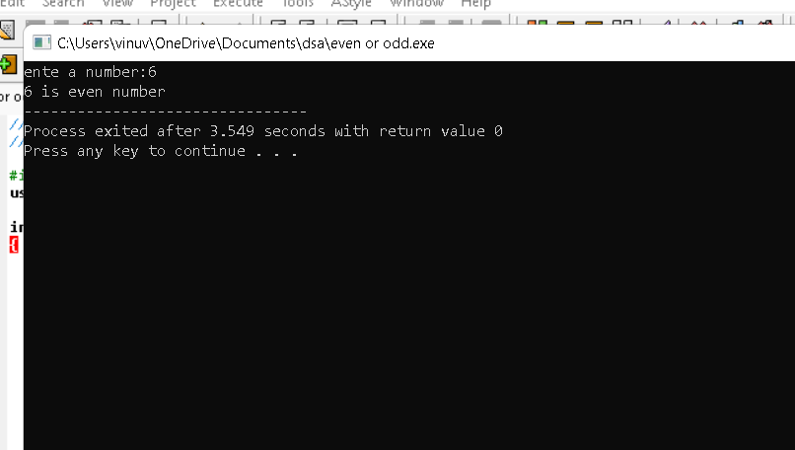

//reverse of number

#include<iostream>

using namespace std;

int main()

{

int n,rev=0,rem;

cout<<"enter a number:";

cin>>n;

while(n!=0)

{

rem=n%10;

rev=rev*10+rem;

n/=10;

}

cout<<"reverse of "<<n<<" is :"<<rev;

return 0;

}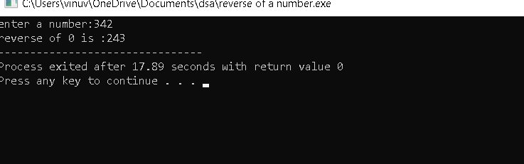

3. //factors of a given number.....

#include<iostream>

using namespace std;

int main()

{

int n,i;

cout<<"enter a number:";

cin>>n;

for(i=1;i<=n;i++)

{

if(n%i==0)

{

cout<<"factors of "<<n<<" is:"<<i<<endl;

}

}

return 0;

}

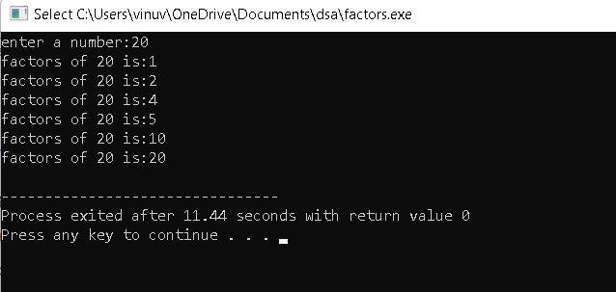

//prime number.....

#include<iostream>

using namespace std;

int main()

{

int n,i,c=0;

cout<<"enter a number:";

cin>>n;

for(i=1;i<=n;i++)

{

if(n%i==0)

{

c++;

}

}

if(c==2)

{

cout<<"prime number";

}

else

{

cout<<"not prime number";

}

return 0; }

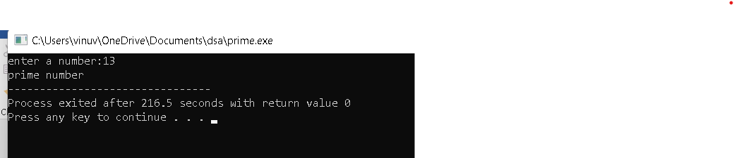

//gcd

#include <iostream>

using namespace std;

int main()

{

int n1,n2,gcd=0,i;

cout<<"enter n1,n2:";

cin>>n1>>n2;

for(i=1;i<=n1 || i<=n2;i++)

{

if(n1%i==0 && n2%i==0)

{

gcd=i;

}

}

cout<<"gcd="<<gcd;

return 0;

}

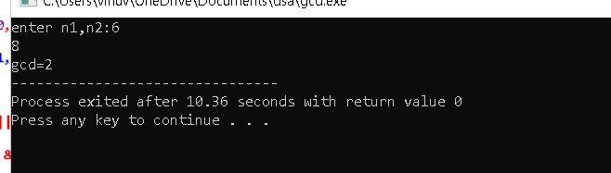

//lcm

#include <iostream>

using namespace std;

int main()

{

int n1,n2,gcd,i,p;

cout<<"enter n1,n2:";

cin>>n1>>n2;

for(i=1;i<=n1 || i<=n2;i++)

{

if(n1%i==0 && n2%i==0)

{

gcd=i;

}

}

p=n1*n2;

cout<<"lcm="<<p/gcd;

return 0;

}

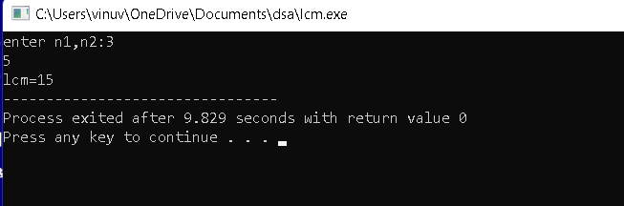

//palindrome of a number…..

#include<iostream>

using namespace std;

int main()

{

int n,rev=0,rem,temp;

cout<<"enter a number:";

cin>>n;

temp=n;

while(n!=0)

{

rem=n%10;

rev=rev*10+rem;

n/=10;

}

if(temp==rev)

{

cout<<"palindrome";

}

else

{

cout<<"not a palindrome";

}

return 0;

}

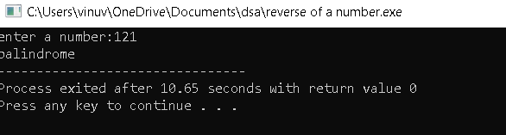

//string palindrome

#include <iostream>

#include<string.h>

using namespace std;

int main()

{

char s[200];

int i,l,c=0;

cout<<"Enter a string: ";

cin >>s;

l=strlen(s);

for(i=0;i<l;i++)

{

if(s[i]!=s[l-i-1])

{

c++;

}

}

if (c>0)

{

cout <<s<<" is not a palindrome"<<endl;

}

else

{

cout<<s<<" is a palindrome";

}

return 0;

}

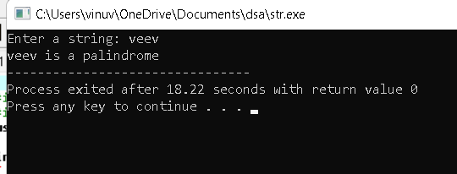

//half pyramid....

#include<iostream>

using namespace std;

int main()

{

int n,i,j;

cout<<"enter a number:";

cin>>n;

for(i=0;i<n;i++)

{

for(j=0;j<=i;j++)

{

cout<<"* ";

}

cout<<endl;

}

return 0;

}

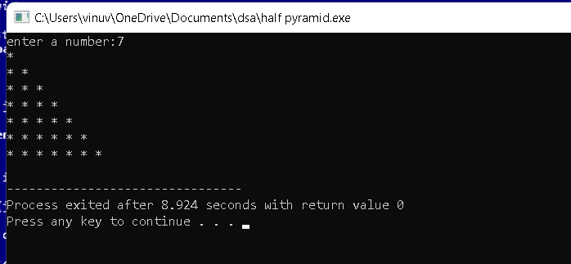

//fibonocii

#include<iostream>

using namespace std;

int main()

{

int a,b,n,i=2,sum=0;

cout<<"enter a,b values:";

cin>>a>>b;

cout<<"enter fibonocci range:";

cin>>n;

if(n>0)

{

cout<<"fibonocci series:"<<a<<","<<b;

}

while(i<n)

{

sum=a+b;

cout<<","<<sum;

a=b;

b=sum;

i++;

}

}

